5/9/2025

Daniel Van Loggerenberg

ST10310998

INSY6212

Assignment 2

Contents

1.1 Why a Project Evaluation Form is Important 2

1.2 Cross-Platform Development in My Project 2

1.3 Key Deliverables in the Project Charter 3

2.WBS 4

3.1: Project Schedule 5

5.1 Peer Evaluation 7

5.2 Self-evaluation: Reflective report 8

# 1.1 Why a Project Evaluation Form is Important

Before to starting a project, it is important to have a clear idea of whether it is worthwhile. A project evaluation form is an organised method to determine whether the project proposal is practical and in line with the goals of the organisation or team.   
Since it offers a shared knowledge of the issue the software is trying to solve, this form would be beneficial for my project, which involves developing a mobile application. Examining several ideas helps to choose the one with most promise. It helps us to create functional strategies, by thinking about time, money, and required resources. It also reduces the likelihood of delays or failure later on, by helping us spot any problems early on. This kind of form guarantees that we begin the project with well-defined objectives, a solid foundation, and the proper motivations.

# 1.2 Cross-Platform Development in My Project

The process of creating an application that functions on many operating systems, such as iOS and Android, using essentially the same code is called cross-platform development. Developers can save time and effort by using tools like Flutter or React Native, which let them create code only once and have it operate on both platforms.  
This method saves a significant amount of time for my project. We can create a universal version rather than individual apps for every device. Given the short 12-month timeline, this will make it easier for us to meet our target.

But there are a few things to remember:

1. The app may not function as quickly as apps designed especially for iOS or Android.

2. Some third-party libraries or tools might not function flawlessly on all platforms.

3. If the design is not thoroughly tested, it may appear a little strange on one platform.

Despite these dangers, cross-platform development is a wise decision because:

* It increases the app's user base It allows for device-to-device consistency in the UI, and it speeds up problem fixes and feature additions.
* It's easier to build features that work offline, which is helpful for users with unreliable internet.

# 1.3 Key Deliverables in the Project Charter

**1. Project Plan:** Objectives, deadlines, assignments, and our approach to work management.

**2. Initial Designs (Wireframes or Mockups):** Graphic representations of how the application will appear and how it will work.

**3. Basic Working App (MVP):** Early test version of the app that just has essential functionalities.

**4. Testing Reports:** Input from quality checks, bug tracking, and user testing.

**5. Deployment Files and Documentation:** User manuals and technical documentation, as well as everything required to formally start the application.

# 2.WBS

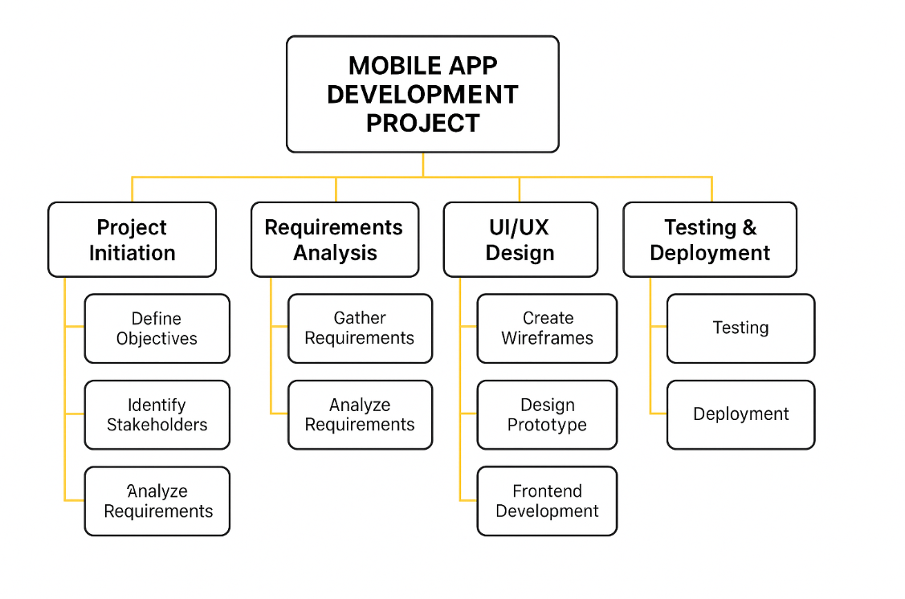

# 3.1: Project Schedule

Milestones

* **M1:** Charter Approval (After Activity 5)
* **M2:** Midway QA Complete (After Activity 20)
* **M3:** Final Deployment (Activity 28)

4.

# 5.1 Peer Evaluation

4

8

2

1

2

2

1

[Grab your reader’s attention with a great quote from the document or use this space to emphasize a key point. To place this text box anywhere on the page, just drag it.]

# 5.2 Self-evaluation: Reflective report

| **Criteria** | **Explanation** |
| --- | --- |
| **Introduction** | This project helped me understand how real-world mobile app development is planned and executed. I learnt the importance of project planning, teamwork, and aligning technical work with deadlines and stakeholder expectations. |
| **Skills learnt** | **Technical:** I gained experience using project planning tools and learned how to create diagrams like WBS and network charts.  **Communication & Teamwork:** I collaborated with teammates, shared ideas, and responded to feedback.  **Management:** I improved time management by meeting deadlines and solving problems when tasks overlapped. |
| **Role in the team** | I contributed by creating diagrams and offering suggestions during discussions. I followed instructions carefully and helped resolve misunderstandings in the group by keeping communication clear and respectful. |
| **Research and Technology** | I researched project management techniques and used tools like Canva and Word to create visuals and reports. I presented my findings in clearly formatted documents and diagrams for submission. |
| **Personal strengths and weaknesses** | **Strengths:** Organized, reliable, detail-oriented, cooperative, quick learner.  **Weaknesses:** I struggled with time pressure during the critical path analysis and need to improve confidence in decision-making. |
| **Stakeholder relationships** | Team communication was smooth, and we respected each other's input. To improve, I could initiate more feedback sessions and ask for help sooner when needed. |
| **Impact** | My planning diagrams and scheduling helped guide the team through task priorities. To make a bigger impact, I could take more initiative in delegating roles. |
| **Conclusion** | This project taught me valuable technical and teamwork skills. It gave me insight into project planning and helped me grow both personally and professionally. |